

Template for the Fights Kids Cancer Competitive Call Full Proposal
Translational Research Template

Submission Deadline: 6 March 2026 12:00 CET (UTC+1; noon)

This box is only for information and should not appear in the proposal
Proposals must respect the following standards:
- A minimum font size of 11 points, except for references, the Gantt chart, and tables where the minimum font size is 9 points
- Arial font
- Line spacing set to 1.15 for improved readability.
- A4 page size
- All margins (top, bottom, left, right) should be at least 15 mm (not including any footers or headers).
- Must be completed in English
If tables are used, they should illustrate the core text of the proposal and should not contain the core text itself. The text should not contain any hyperlinks in the core text. Each page should contain a header with the proposal acronym. All pages should be numbered in a single series in the footer using the following numbering format “Page X of Y”.
The description of the proposed research project should be completed off-line (consisting of Part A and Part B) and then uploaded as a pdf. It is the responsibility of the applicant to verify that the submitted PDF documents are readable. Page limits are absolute, and any applications which exceed the limits will be rejected.

Part A
The maximum total length for this part is 9 pages. Excess pages (per section and overall) will not be considered. It is the responsibility of the applicant to verify that the submitted PDF documents are readable and are within the page limit. It should be composed as follows:
- Section 1: Scientific excellence & implementation (7 pages maximum)
- Section 2: Impact (2 pages maximum)
The elements to be included in Part A are described below.
Please refer to the Section 9 of Guidelines for Applicants for further elaboration on FIGHT KIDS CANCER’S expectations and evaluation criteria.
Part A, Section 1: Scientific excellence & implementation – 7 pages maximum
- Quality and reliability of the research project
In this part, you should provide an introduction, a state-of-the-art, specific hypotheses and objectives plus a general overview of the project. The research methodology and the approach should also be described. The originality and the innovative aspects of the research project should be highlighted and explained, especially regarding how the project is expected to make advancements in the field of paediatric oncology. Any novel concepts, approaches and methods that will be implemented should be described.
- Quality of the team/institution
You should describe the qualifications and experience of the principal investigator(s), as well as the team in general. You must provide information regarding the level of experience on the research topic proposed and a narrative track record of work (main international collaborations, level of experience in supervision of PhD and postdoctoral researchers, publications, past and on-going projects, and any other relevant results). Finally, the research project should also show that it will be well-integrated within the team/institution. Short and concise CVs will have to be joined in the Annex (see below Part B section 4 for details).
- Implementation
In this part, you should describe the work planning (Work Breakdown Structure, including deliverables and milestones) and provide an outline of the project management structure and approach.
The proposed schedule (in months) must be detailed from the start of the project. The associated Gantt chart, which includes Work Packages titles, indication of major deliverables and milestones, should be joined as an Annex (see below Part B section 4 for details).
Resources (technical, expertise and skills) required to support the methodology and to reach the project objectives should be described. You should also indicate the planned number of person-months and how they are to be used in the different tasks (note that detailed cost justification should be provided in section 3).
A risk analysis and associated risk management plan should be provided as an annex (see below Part B section 4 for details).
Part A, Section 2: Potential Impact – 2 pages maximum
    - Clinical relevance and translational potential
    - Clinical relevance
Applicants are invited to provide a statement explaining the clinical relevance of the proposed project and its potential for translation into clinical practice. The statement should anticipate the possible clinical development of the project and describe how the expected research outcomes could address clinical challenges (for example, how potential toxicity may be addressed).
    - Justification of the disease model
Applicants should justify the choice of the disease model regarding its relevance for clinical application.

    - Pathways to impact for children and adolescents with cancer

This section should summarise how the research activities during and after the project will contribute to the FKC programme objectives:
    - To realise real impact on young patients: Improve their survival rate and reduce toxicity to restore young patients to full health after treatment.
    - To advance cutting-edge science to further the knowledge of paediatric malignancies.
    - To support improved interdisciplinary research, methods, and collaborations for tackling the issues of today.
    - To strengthen collaboration and the development of scientific capacity across Europe.

  - Quality of the proposed measures to exploit and disseminate the project results to targeted peers (e.g. scientific, industry)
In this part, you should describe the dissemination and exploitation of the knowledge that will be generated by the project. Potential impact should also be described. The planning of the dissemination and exploitation activities should appear in the Gantt chart (see Part B section 4).
  - Quality of the proposed measures to communicate the project activities and results to the public
In this part, you should demonstrate how the public engagement activities will contribute to create awareness around the research and the results, especially in a way that can be understood by the general public. The planned activities should also be included in the Gantt chart.

Part B:
- Section 3: Budget & justification
- Section 4: Annexes (Gantt chart, Risk management, CV, References)

Part B, Section 3: Budget and Justification – 2 pages maximum
The Justification of Resources should state the full cost of the project and explain why the requested resources are needed, including identifying how the proposal presents good value for money.
All costs associated with the project must be itemised (using the table templated below) and fully justified (text to be provided in addition to the table). Cost items that are not properly justified may be removed from the proposed grant.
If contingency costs cannot be clearly identified, itemised and justified, they cannot be included in the project budget.
Complementary funding and in-kind support should be mentioned here and supported by letters of support, to be provided in annex 6.

Budget table
(Excel spreadsheet below, to adapt according to the number of partner and number of year).
The completed Excel table must be inserted into the full proposal and uploaded separately as an Excel file in the designated field.

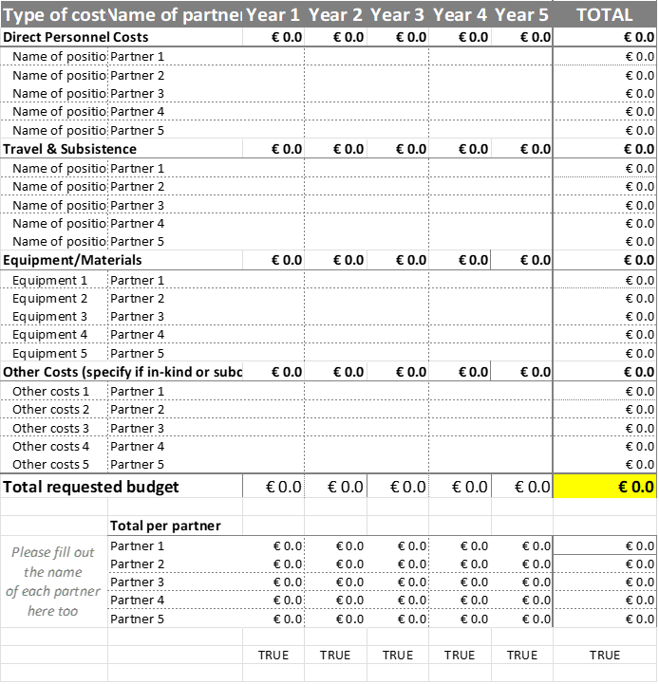

Part B, Section 4: Supporting Annexes
The following Annexes must be provided with the proposal:
- Annex 1: Gantt chart (1 page max)
The Gantt chart should illustrate the work schedule of the project, it should include:
  - Deliverable: Distinct output of the research project, important for the research project’s overall objectives. It may consist of a report, a document, a publication, etc. The numbering of deliverables should be ordered according to delivery dates. Please use the following numbering convention: “WP number. Number of the deliverable within that WP”. For example, deliverable 1.2 is the second deliverable of the work package 1.
  - Milestones: Defined control points in the research project that help to structure the progress of the project. They may correspond to the completion of key deliverables, necessary for the next step of the project, or intermediary results or achievements that may operate as a checkpoint to apply corrective measures if necessary.

- Annex 2: Risk management (1 page max)
This part should present and discuss relevant research/administrative risks that might occur and impact on the project implementation. Associated risk management and mitigation measures should be described.

- Annex 3: Lay language summary of the project (1/2 page max)
This is a description of the project in lay terms which must be understandable by the general public and include the following information:
  - Indication targeted by the project and general information on the indication:
    - # patients per year in Europe generally
    - # patients in relapse/high risk per year in Europe if relevant
    - Overall chances of survival of target group of patients and / or information about toxicity and long-term side effects
  - Purpose of the project’s intervention
  - Nature of the project’s intervention
  - Next steps for patients after the conclusion of your project (clinical trial, phase II or III trial, amendment of standard of care…)

- Annex 4: Project team CVs
CVs of the principal investigator(s) and co-investigator(s) should be attached in annexes, with a maximum of 2 pages per CV. CVs should include current and previous positions, a maximum of 10 most relevant publications and obtained research funding. It is recommended that CVs use a consistent template within projects.
- Annex 5: References (2 pages max)
In general, the citations and the bibliography should follow The Lancet citation style. References need to be cited in the text sequentially in the Vancouver numbering style, as a superscripted number (Arabic numerals: 1, 2, 3, 4…) after any punctuation mark. Two references are cited separated by a coma without space, three or more consecutive references are given as a range using an en rule (i.e. 1–4). References should be listed on a new page, titled ‘References’, in the Annexes. It needs to include all the references you have cited in the text. The journal titles should be abbreviate using the style from the NLM.
- Annex 6: Letters of Support
Letters of support should be included to provide evidence of existing engagement with relevant users, partners, researchers, drug availability etc. For example, the types of letters an applicant should include are:
- Letter of support from complementing project/funding
- Letter of support from the applicant’s organisation

Letters of support are required from any named Project contribution – up to 2 pages:
- For research involving investigational drug(s), applicants should include a letter of support that the drug will be provided (for both pre-clinical and clinical research)
- The letter of support should confirm the organisation’s commitment to the proposed project, identify the value, relevance, and possible benefits of the proposed work to the partner, the period of support, the full nature of the collaboration and how the partner will be involved in the project and provide added value
- Applicants should include any in kind and or leveraged support that has been secured for the proposal through the attachment of a letter from the Project Partner or Collaborating Project.

Any letter of support should be written when the proposal is being prepared and related specifically to the project.

Ethics self-assessment
to the Fight Kids Cancer Competitive Call

Information about your application, including the personal information provided on the forms, will be processed and stored electronically by the European Science Foundation (ESF) Secretariat and representatives of the Call’s Funders. In accordance with the selection process, the Information contained in your application may be passed on to external reviewers in confidence. Reviewers will be asked to destroy information after the review and selection process is completed.
Your application and personal information will be stored by the ESF electronic system for programme management purposes but will not be shared with other organisations outside the FKC partnership. We will use details provided in the application for correspondence about the call and may also use this information for future analyses of the performance of the programme.
By submitting your application to the FKC Programme you have indicated your acceptance of these data protection terms and conditions.

Completion of the tables below constitutes part of the proposal submission for the FKC call and must be uploaded at the time of submission.

For details about ethics requirement and information/documents to provide later, please refer to the ethics guidelines.

Section 1: Human Embryonic Stem Cells (hESCs) |  |  | YES | NO | Page (in the proposal)
Does your research involve Human Embryonic Stem Cells (hESCs)?
If YES: | Will they be directly derived from embryos within this project?
If YES: | Are they derived from established cells line?
Section 2: Humans
Does you research involve human participants?
If YES: |  | Are they persons unable to give informed consent (including children/minors)?
 |  | Are they patients?
Does your research involve physical interventions on the study participants?
If YES: |  | Does it involve invasive techniques (e.g., collection of human cells or tissues, surgical or medical interventions, invasive studies on the brain, etc.)?
 |  | Does it involve collection of biological samples?
Section 3: Human Cells/Tissues
Does you research involve human cells & tissues (other than hESCs, see section 1)?
If YES: |  | Are they available commercially?
 |  | Are they obtained within this project?
 |  | Are they obtained from another project or institution?
 |  | Are they obtained from a biobank?
Section 4: Protection of personal data
Does your research involve processing of personal data?
If YES: |  | Does It involve the processing of special categories of personal data (e.g. genetic, health, sexual, lifestyle, ethnicity)?
 |  | Does it involve processing of genetic, biometric or health data?
Does your research involve further processing of previously collected personal data (including use of pre-existing data sets or sources, merging existing data sets)?
Does your research involve publicly available data?
It is planned to export personal data from non-EU countries into the EU?
It is planned to import personal data from non-EU countries into the EU?
Section 5: Animals
Does your research involve animals?
If YES: |  | Are they vertebrates?
 |  | Are they genetically modified?
Section 6: Third countries
In case that participants from countries that are not designated in Annex A are involved, do the research related activities undertaken in these countries raise potential ethics issues?

Specify the countries involved:
Section 7: Health and safety
Does your research involve the use of elements (chemicals, radioactive material) that may cause harm to humans, including research staff?

For research involving human participants, see section 2.
Section 8: Misuse of research results
Does your research have a potential for misuse of research results?
Section 9: Other ethics issues
Are there any other ethics issues that should be taken into consideration?

Please specify:

