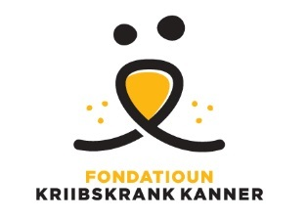

Imagine for Margo & Fondatioun Kriibskrank Kanner & KickCancer,

|  |  |
| --- | --- |
|  | *FIGHT KIDS CANCER*  Supporting a PROGRAMME FOR INNOVATIVE RESEARCH |

**Online pro-forma example to the Fight Kids Cancer Competitive Call**

Fight Kids Cancer Competitive Call

|  |
| --- |
| *Critical Deadlines: Full Proposals to be submitted by 1st of April 2020 16:00 (4pm) Brussels time* |

Information about your application, including the personal information provided on the forms, will be processed and stored electronically by the European Science Foundation (ESF) Secretariat and representatives of the Call’s Funders. In accordance with the selection process, the Information contained in your application may be passed on to external reviewers in confidence. Reviewers will be asked to destroy information after the review and selection process is complete.

Your application and personal information will be stored by the ESF electronic system for programme management purposes but will not be shared with other organisations outside the FKC partnership. We will use details provided in the application for correspondence about the call and may also use this information for future analyses of the performance of the programme.

By submitting your application to the FKC Programme you have indicated your acceptance of these data protection terms and conditions.

**Presented below is an example of the questions to be completed in the online pro-forma. This functionality will become available 15 Jan 2020**

|  |  |  |  |  |
| --- | --- | --- | --- | --- |
| Type of project  (tick one) | Clinical | | Translational | |
| Project title (max 200 characters) |  | | | |
| Project acronym |  | | | |
| Project objectives (max 4000 characters with space) |  | | | |
| Laypersons summary  (max 4000 characters with space) |  | | | |
| Key Words (200 characters max) |  | | | |
| Requested budget total |  | | | |
| PI name (Fist Name, Last name) |  | | | |
| PI email contact |  | | | |
| PI ORCID number (optional) |  | | | |
| PI organisation |  | | | |
| PI Country |  | | | |
| PI Gender | Male | Female | | Other |
| CO-I Name  CO-I Country  CO-I Organisation  (list all) |  | | | |